Working with Expanse Services: What to Expect
Notes
Todo: Minimal version, detailed version
Large version could be intimidating? May want a simple version? Can input doc into AIs and get simplified version
Development maybe intimidating
Layout Options: Timeline?
Also, over time. Can just put in text for now.
Introduction ( Need new title )
At Expanse Services, we're not just software developers; we're passionate innovators driven by a commitment to transparency, continuous improvement, and optimization. We meticulously craft top-notch software solutions, always striving to deliver them on time and within budget. Our commitment to equity and equality extends beyond our work, creating a nurturing environment where individuals from all walks of life can flourish and reach their full potential.
Add Context to the document, what is this for, maybe table of contents
Add client benefits
Client Benefits & Outcomes: Emphasize the benefits your company brings to clients, such as reduced risks, improved time-to-market, and increased cost-efficiency. Showcase successful client case studies and testimonials to demonstrate your track record of delivering high-quality software solutions.

What to Expect Email
We embark on your digital journey with a comprehensive needs assessment, delving into your business goals and user needs. We then transform your vision into detailed wireframes and prototypes, bringing your ideas to life. Throughout the development process, we continuously adapt and fine-tune our approach, focusing on the most critical elements first. This ensures that your project remains on track and delivers the features and functionality you need to achieve your goals while minimizing risks, expediting time to market, and optimizing cost efficiency.

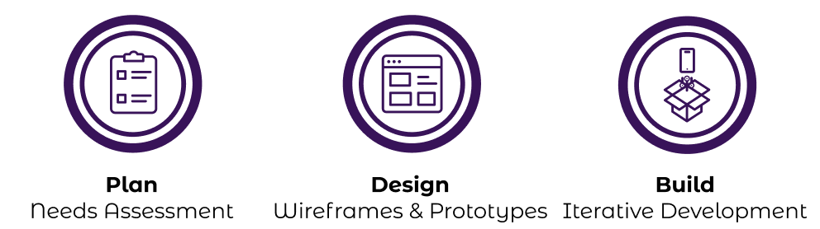
For more details on the full process check feel free to review the attached PDF or view it online here

Project Approach and Methodology
Our streamlined process seamlessly guides your project from vision to reality. Our three core phases – Planning, Design, and Build – ensure clarity, efficiency, and continuous improvement.
We begin by conducting a thorough needs assessment to fully understand your goals and challenges. Next, we transform your vision into comprehensive designs that outline the user experience, functionality, and technical architecture. Throughout the development process, we employ an iterative approach, prioritizing the most critical elements first. This ensures that your project stays on track and delivers the features and functionality you need to achieve your goals while minimizing risks, expediting time to market, and optimizing cost efficiency.
Home Page Version
We embark on your digital journey with a comprehensive needs assessment, delving into your business goals and user needs. We then transform your vision into detailed wireframes and prototypes, bringing your ideas to life. Throughout the development process, we continuously adapt and fine-tune our approach, focusing on the most critical elements first. This ensures that your project remains on track and delivers the features and functionality you need to achieve your goals.


Planning Phase

Step 1: Embark on Your Digital Journey: Discussing Your Vision
The first meeting marks the beginning of an exciting journey to transform your vision into a reality. This crucial step lays the groundwork for a successful collaboration, ensuring that your goals, expectations, and needs are clearly understood and aligned.

Articulate Your Vision, Goals, and Expectations
This is your opportunity to share your vision for the project, outlining your goals, objectives, and desired outcomes. Expanse will actively listen and ask clarifying questions to gain a comprehensive understanding of your requirements and aspirations.

Define the Project Scope and Deliverables
Together, you will start to define the project's scope, outlining the specific features, functionalities, and deliverables that will bring your vision to life. This collaborative process ensures that both parties are on the same page, preventing scope creep and ensuring that the project remains focused on achieving your desired outcomes.

Establish Realistic Timelines and Budget
The discussion will delve into the project's timeline, considering its complexity and your budget constraints. Realistic timelines will be established, ensuring that your project progresses smoothly and stays within your financial parameters.

Explore Technology and Design Options
Expanse will provide insights into potential technology stacks and design approaches that align with your project's requirements and aesthetic preferences. This exploration will help you understand the technical feasibility and envision the overall look and feel of your website or application.

Address Concerns and Questions
Your questions and concerns are taken seriously. This is the time to address any doubts or uncertainties you may have about the project. Expanse will provide clear and comprehensive answers, ensuring that you feel confident and informed throughout the process.

Establish Next Steps and Communication Channels
The meeting concludes with a clear understanding of the next steps, including follow-up actions, communication channels, and timelines for project updates. This leaves you with a roadmap for the path ahead, ensuring that you stay informed and involved every step of the way.
As you embark on this exciting journey, remember that Expanse is here to guide you and support you. My expertise and dedication will be instrumental in transforming your vision into a successful digital solution.

Step 2: Crafting a Comprehensive Project Proposal
In this phase, we meticulously refine the project's scope, deliverables, and timeline, ensuring perfect alignment with your vision and objectives. We also delve into your design preferences and create wireframes to shape your digital blueprint.

Refining Project Scope and Deliverables
Through comprehensive collaboration, we refine and expand upon the project's scope, deliverables, and objectives, ensuring we capture every aspect of your vision and requirements.

Prioritizing Requirements
We work together to identify and prioritize mandatory, optional, and deferred requirements. This prioritization ensures that we allocate resources efficiently and focus on the most critical aspects of the project first.

Establishing Testing Strategies
We discuss testing requirements, preferences, and methodologies to establish a comprehensive quality assurance plan. This plan ensures that your project is rigorously tested throughout the development process.

Defining Release Preferences
We determine the desired release cadence, whether it's continuous deployment or scheduled releases. This decision is based on your preferences, project complexity, and business needs.

Finalizing the Project Proposal
We complete the formal project proposal, outlining the scope, deliverables, timeline, budget, and risk mitigation strategies. This proposal serves as a comprehensive roadmap for the project's execution.

Discussing Integration Requirements
We discuss integration requirements, including social media integrations, third-party APIs, and legacy systems. This ensures that your project seamlessly integrates with your existing infrastructure.

User Experience Planning
We meticulously plan the user experience (UX) to ensure a seamless and intuitive user journey. This includes writing user journeys, creating user stories, and gathering design preferences.

Gathering Design Preferences
We understand your design preferences, including color palettes, typography, and overall aesthetic direction. This ensures that the project's design aligns with your brand and vision.

Categorizing Images
We classify images based on their intended use, such as product images, background images, or hero images. This organization facilitates efficient image selection and management throughout the design process.

Ranking Featured Elements
We determine the priority of featured items or images to prioritize their placement and prominence. This prioritization ensures that the most important elements are showcased effectively.

Creating Wireframes
We utilize wireframes to visualize the layout and structure of key pages, providing a rough outline of the user interface. This low-fidelity approach allows for early feedback and iteration.

Deciding on High-Level Technical Architecture
We collaborate to decide on the high-level technical architecture, including the choice of programming languages, frameworks, and tools. This decision is based on the project's requirements, scalability needs, and future growth plans.

Moving Forward
By following these steps, we can craft a comprehensive project proposal that accurately reflects your vision and objectives. This proposal will serve as a valuable guide throughout the project's development and ensure that we deliver a solution that meets your exact needs.

Design Phase
Envisioning Success: Transforming Your Vision into Interactive Prototypes and Robust Technical Architecture
Before delving into the intricacies of coding, we embark on a comprehensive design journey, encompassing both visual and technical aspects. We utilize the power of Figma, an interactive prototyping platform, to translate your vision into high-fidelity mockups. This collaborative space allows us to refine and iterate on the design before committing to code. Simultaneously, we lay the foundation for a robust technical architecture, ensuring optimal performance, scalability, and security.

Visualizing Success: Translating Your Ideas into Prototypes
Our design process begins with Figma, an interactive platform that enables us to bring your project to life through mockups and prototypes.
- Designing for User Experience: We prioritize user experience, designing intuitive layouts, navigation structures, and process flows that enhance user interactions.
- User Interface Components: We meticulously create individual user interface components considering usability, accessibility, and visual appeal. We maintain consistency across the entire project, ensuring that every element—from intuitive buttons to aesthetically pleasing icons—is seamlessly integrated and enhances the user experience.
- Gathering Content Sources: We identify and gather relevant content, including text, images, and videos, to ensure a rich and engaging user experience. This content serves as the foundation for crafting compelling narratives and visuals.
- Gathering Exact Values: We gather precise values for elements like email addresses, phone numbers, and images, including logos and other graphical elements, to ensure accurate representation throughout the website or application.

Design Example 1: Work In Progress Wireframes
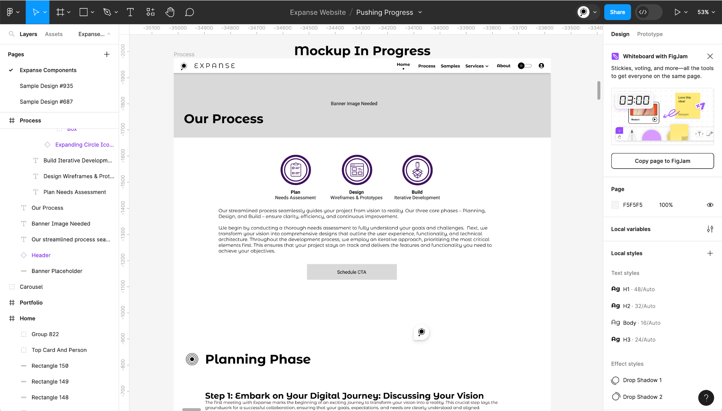
Design Example 2: Component Development, Higher Detail
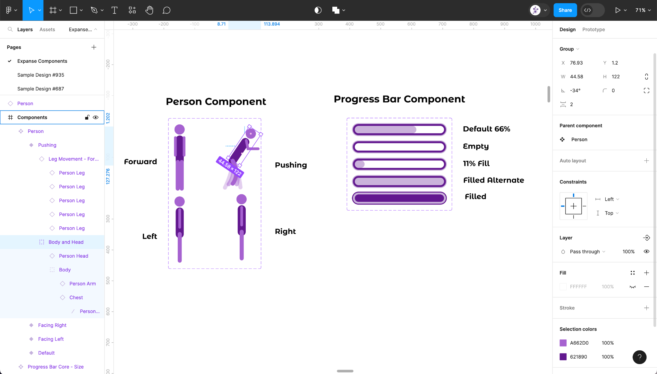

Unveiling the Technical Blueprint
As we meticulously craft the visual elements of your web application, we simultaneously lay the groundwork for its technical backbone. This includes:
- Defining API Design Specifications: We collaborate with you to define the API design specifications, ensuring seamless integration with third-party services and data sources.
- Designing Infrastructure: We carefully design the infrastructure of your website or application, ensuring optimal performance, scalability, and security. We consider factors such as traffic volume, data growth, and security protocols to ensure that your application can handle the demands of your users and protect their data.
Example Technical Design: API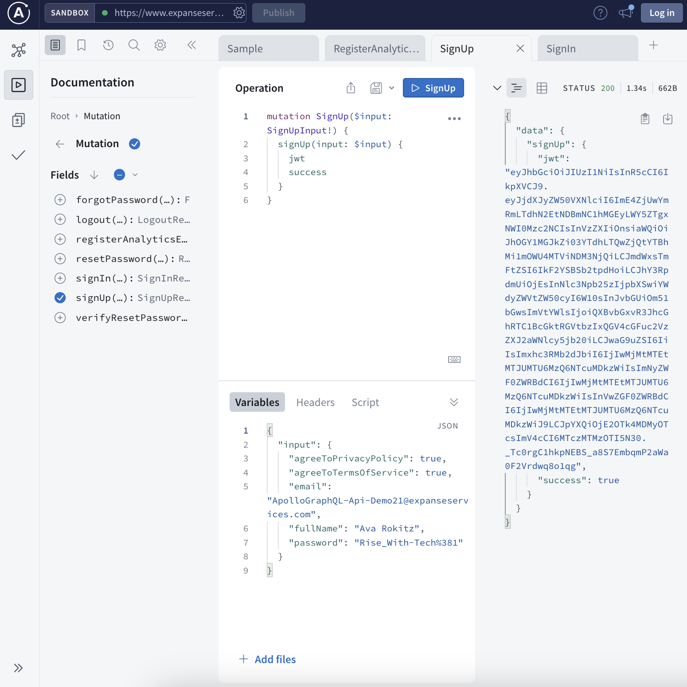
Example Technical Specification Document
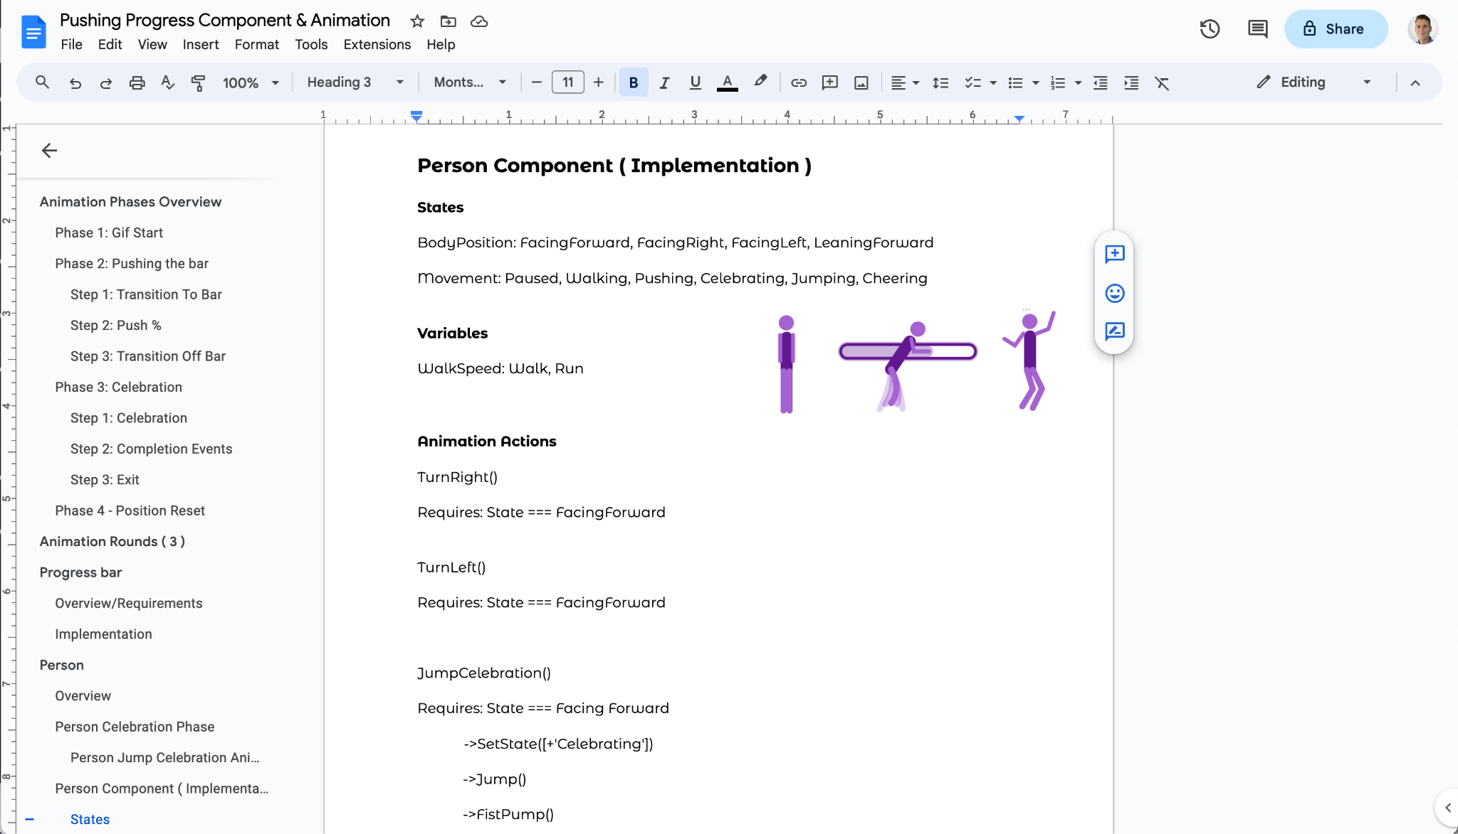

Development Phase
Powered by state-of-the-art technology, our development process creates applications with lightning speed. With JavaScript and TypeScript as our foundation, we specialize in delivering products that offer performance, scalability, and reusability. Our solutions seamlessly operate within cloud or self-hosted platforms.
Preferred Technologies
- UI: React, Angular, JavaScript
- Server Side: Docker, Express, Node.js
- Databases & Data: MySQL, MongoDB, JSON
- Open Source & Tooling: OpenAI, Git, Webpack
- Design Patterns: GraphQL, REST, Serverless

Application Hosting, Deployment, and Operations
Whether you're managing your own solution or seeking assistance with deploying to a cloud environment, count on us to launch your application seamlessly. Looking for unmatched scalability through serverless solutions and swift content delivery? We've got you covered.
Expanse offers:
- Cloud Hosting with services such as Gcp, Aws, and Acp
- Serverless Computing solutions through AWS Lambda, Google Cloud Functions, and alternative providers
- Streamlined Development Processes including Version Control Strategies for Branching and Committing, Deployment Pipelines, and Continuous Integration
This Includes:
- Server Setup with Physical Machines, Ram, Cpus, load balancing, dns, and common backend setups
- Data Repositories such as Relational Databases, NoSQL Databases, and File System Storage
- Cloud Service Implementations encompassing text Messaging, Emailing, and Text-To-Speech

Agile Development
In order to keep projects organized and ensure unified communication, Jira is our tool of choice. Explore the interface depicting intricacies of software project management through the accompanying image, showcasing vital elements like tickets, complexity estimates, statuses, prioritization, and epics.
Example Ticket Management System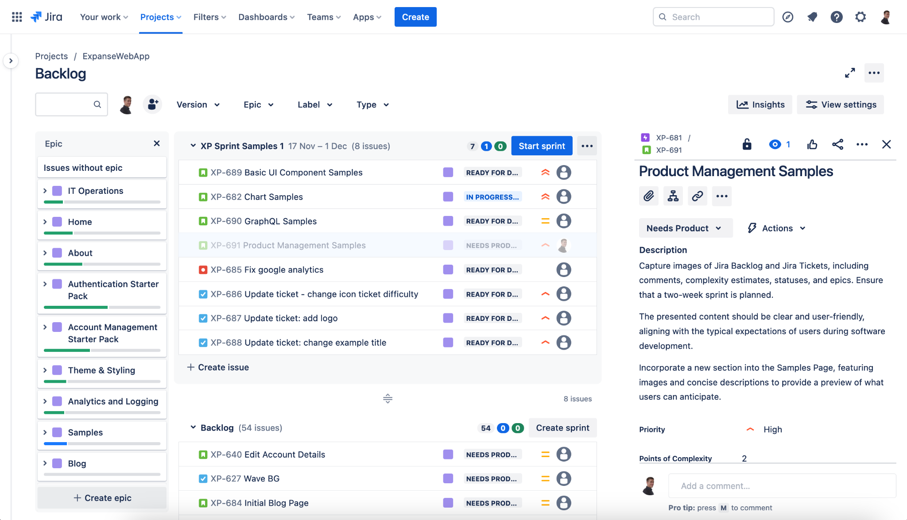
Example Work In Progress View
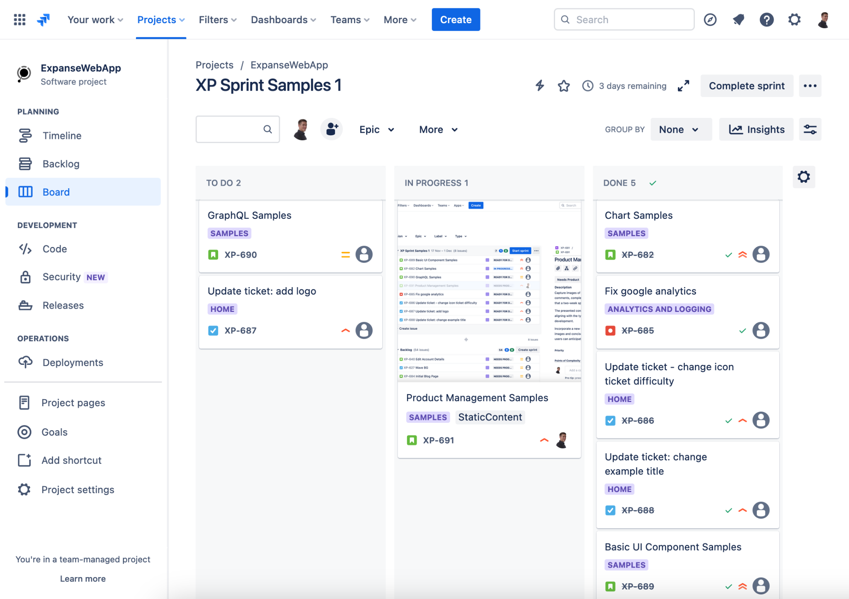

Predicting Project Complexity: Development Estimation Techniques
We employ a point-based system to gauge the complexity of tasks, akin to estimating the approximate completion time without assigning it to a specific individual. This approach fosters a more objective and consistent assessment of effort across tasks, paving the way for a more streamlined and efficient development process. This point-based agile development model elevates development to a new level of precision and predictability.
Example Point Estimation
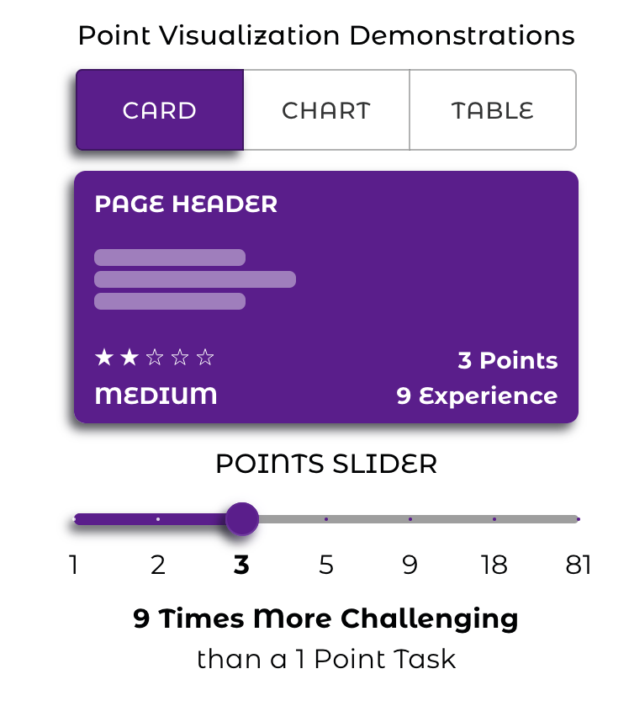

Contact Information and Next Steps
- Provide clear contact information for inquiries and project discussions.
- Outline the next steps for initiating a project, including proposal submission, contract negotiation, and project kickoff.
Client Benefits and Outcomes ( Top ? )
- Emphasize the benefits your company brings to clients, such as reduced risks, improved time-to-market, and increased cost-efficiency.
Showcase successful client case studies and testimonials to demonstrate your track record of delivering high-quality software solutions.

Additional Information

Eventual Link: Project Timeline, Pricing, and Quotes ( Page )

Eventual Link: Software Testing

Eventual Link: Deployment & Maintenance

Eventual Link: Task & Ticket Management

Eventual Link: Communication & Progress reporting during projects
Project Timeline

FAQs
We dynamically adapt our methodology based on the specific demands of each client and project, employing a variety of testing, quality assurance, and development strategies, communication methods, and process adjustments to achieve optimal results.

Communication and progress reporting during a project
- Track the progress of features and tasks in online product management dashboards.
- Stay in the loop with project-specific Zoom meetings.
- Receive instantaneous updates via Text, Email, and/or Slack, keeping you informed about project events through team messages.
<Depends on the project>
Q: How do you keep clients informed about project progress?
We prioritize clear and consistent communication throughout your project. Track progress in real-time through our online dashboards, attend project-specific Zoom meetings, and receive instant updates via Text, Email, or Slack. Our communication style adapts to each project's unique needs.
- Highlight your commitment to open and transparent communication with the client throughout the project lifecycle.
- Explain your use of project management tools and regular meetings to keep the client informed and involved in decision-making.
- Track the progress of features and tasks in online product management dashboards.
- Stay in the loop with project-specific Zoom meetings, including roadmap updates, backlog grooming, and daily stand-ups.
- Receive instantaneous updates via Slack, Text, or Email, keeping you informed about project events through team messages.
Development Practices
- Highlight your development practices, including coding standards, code reviews, to ensure high-quality code and software stability.

Deployment and Maintenance
Explain your deployment process, including staging environments, rollouts, and user training to ensure a smooth transition to production. Describe your maintenance and support plans to address any post-deployment issues and provide ongoing updates and enhancements.

Software Testing & Quality Assurance ( Page )

Design Options / Design Explained

Task and Ticket Management
The chunked categories and pieces are broken down further and put into our project management software. Additional details are added to the tickets such as descriptions and types of work types. Tickets have status tracking (generalized as Todo, Doing, Done) and allow for commenting, assignment, and prioritization. They enable communication and record keeping track for what is and has been done with each piece of work.

~Breaking It Down: Simplifying the Project ( Simplification & Chunking)
Break down work into categories and organized sections and types of work to be done. We are breaking down the work into smaller bite sized pieces that we use to track the progress of your project. To keep things organized we have categories
Example:
We want a website with a header, footer, navigation, a home page and an about us page.
→
Web Hosting
Domain
Emailing
Credentials
Cloud platform setup
Databases
Design, Development, Content
Layout
Header
Footer
Navigation
Home Page
Banner
Hero Section & Text
Featured Content & Text
Call To Action
Testimonials
About Page
Mission Vision Values Section
Team Members
Contact Information
FAQs
Components
Call to Action
Contact Us
Social Media Links

Project Timeline, Pricing, and Quotes

Understanding Project Costs and Timeframes
At Expanse, we believe in transparency and clarity throughout the project development process. Our approach to quoting, pricing, and timeline ensures that you have a comprehensive understanding of the project's scope, costs, and expected delivery dates.

Initial Estimation and Formal Quote
Upon receiving your project requirements, we provide a preliminary estimate based on the project's scope, complexity, and our expertise with similar projects. Once you agree to this preliminary estimate, we gather more detailed information, prepare formal requirements, and present you with a comprehensive quote outlining the estimated costs, including labor, materials, and software licenses.

Project Timeline
The project timeline is determined based on the project's complexity and the availability of resources. Once we have a clear understanding of your requirements, we provide a preliminary timeline for project completion. If the preliminary estimate is approved, we move into the formal requirements phase, where we finalize the timeline, define milestones, and establish clear expectations.

Contract Types
We offer a variety of contract types to suit the specific needs of each project. Our contract types include:
- Fixed-Price Contract: Expanse commits to delivering the project for a predetermined fixed price, regardless of the actual effort or time required. This approach is suitable for projects with well-defined scope and minimal uncertainty.
- Time and Material (T&M) Contract: Expanse charges the client for the actual time spent on the project and the cost of materials used. This approach offers flexibility and adaptability for projects with evolving requirements or unforeseen complexities.
- Value-Based Contract: Expanse and the client agree on a value proposition and define milestones with associated value increments. Payment is based on the value delivered at each milestone. This approach focuses on value realization and aligns incentives between the client and Expanse.
- Hybrid Contract: A combination of fixed-price and T&M elements, often used for projects with a defined scope but some uncertainty in complexity. This approach balances predictability and flexibility.

Choosing the Right Contract
The choice of contract type depends on the project's scope, complexity, risk profile, and the risk tolerance of both the client and Expanse. We carefully evaluate each project and recommend the most suitable contract type to ensure a successful project outcome.

Commitment to Transparency
Throughout the project lifecycle, we maintain open communication and provide regular updates on progress, costs, and any potential challenges. We believe in transparency and collaboration to ensure that your project aligns with your expectations and delivers the desired results.

